The First Two-Party System

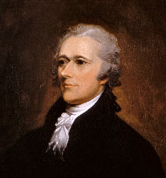 | FEDERALISTS | Leaders | [Jeffersonian]  REPUBLICANS | 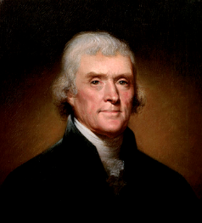
 |  | Federalism
 |  | Fears
 |  | Constitution
 |  | Support Base
Gov Involvement
in Economy
 |  | National Bank
 |  | Protective Tariff
Federal Assumption
of State War Debts
 |  | Foreign Policy

For more instructional materials, visit my website: www.tomrichey.net

