2019 Summer Assignment
Advanced Placement United States History II
Lodi High School
99 Putnam Street
Lodi, NJ 07466

Welcome to 2ndyear AP US History. Your summer assignment consists of four sections. All responses will be submitted through TURNITIN.com and are due August 15 and August 25, respectively.
Turnitin class ID # 20735795
Enrollment Key- APRULES

Please sign into REMIND.COM BEFORE the end of the 2018-19 school year.
Class Code: apispoppin
(get it? AP is poppin!)
Log in at https://www.remind.com/join/apispoppin

This is not busy work. The summer assignment is designed to help you build a body of knowledge before I teach you how to write in the content area of history.
All work should be in MLA format (12 pt. font, 1-inch margin, times new roman) and reflect your BEST effort. If you have any questions, please email me at: michael.tuttle@lodi.k12.nj.us

The 2019-2020 school year Summer Assignment for A.P. U.S. History 2 will consist of 2 components. The first component will involve content comprehension via the online textbook (McGrawhill-Connect). To check for understanding, there will be a test consisting of Multiple Choice and Short Answer questions that will be given within the first full week of school. The second component of the summer assignment will include a research paper. The research paper will be due prior to the school year beginning. The instructions for the research paper are below.

- Component #1 of Summer Assignment: LearnSmart Readings via online textbook. During the first full-week of school, there will be an assessment on these readings including Multiple Choice questions and Short Answers.

    - Complete LearnSmart Reading #1: Chapter 16: The Conquest of the Far West
    - Complete LearnSmart Reading #2: Chapter 17: Industrial Supremacy
    - Complete LearnSmart Reading #3: Chapter 18: The Age of the City
      - There will be a test that follows - given within first full week of school: regarding these 3 chapters: AP style Multiple Choice and Short Answer Questions

    - Due Date to complete LearnSmart Readings: August 15th, 11:59AM

- Component #2 of Summer Assignment: Research Paper: All submissions should be sent via Turnitin.com by the established due date: August 25th, 11:59AM

  - Intro paragraph:
    - Providing Context of the prompt
    - Thesis statement provided based on prompt

  - Body Paragraph #1:
    - 2 sources researched: 2 sources that corroborate with one another

  - Body Paragraph #2:
    - 2 sources researched: 2 sources that require comparison due to dissimilarity in perspective

  - Body Paragraph #3:
    - 2 sources researched: 1 secondary source and 1 primary source

  - Conclusion Paragraph: revealing the significance of the topic.

PROMPT: Discuss the political, economic and social reforms introduced in the South between 1864 and 1877. To what extent did these reforms survive the Compromise of 1877?

DUE DATE: August 25th, 11:59AM

Formatting & Details for Research Paper

- MLA Format Guidelines: https://owl.purdue.edu/owl/research_and_citation/mla_style/mla_formatting_and_style_guide/mla_formatting_and_style_guide.html (also look below at “MLA Citations - A Crash Course”

- Resource List (Databases) + login info: https://docs.google.com/document/d/1dPl5_V93nMceBgRRQfmsMqHHzbyEeRo8kTVCj0PqEwY/edit

Assignment Details:
- This is an individual assignment. Any cases of plagiarism will reflect upon both parties involved. Repercussions, can and may include removal from the course.
- The essay should be in MLA format
  - MLA heading/format (click insert, header)
  - Times New Roman or Arial Font (Size 12)
  - Double spaced lines
  - No extra line between paragraphs
  - 1 inch margins and headers
  - Title required - No title page or table of contents
  - Works Cited Page (may use Easybib)
- Grading: you will be graded based on the rubric below.

Component | Explanation | 10  (Exceeds) | 8-9  (Satisfactory) | 7  (Needs improvement) | 6  (Didn’t read instructions)
Contextualization  (Intro paragraph) | The writer presents and explains the broader historical events/developments relevant to the question. The reader is able to understand the circumstances surrounding the situation. The writer addresses all parts/sub-questions that must be addressed.
Thesis Statement A.K.A. THREESIS Statement  (Intro paragraph) | The thesis statement is in the form of a declarative sentence that states clearly the main argument that the author is trying to make; states three reasons to support argument at the end of the introduction paragraph in one sentence. Student MUST USE “Although…” to begin their thesis statement.
Topic Sentence (each body paragraph) | Topic sentence, or sub-thesis, is aligned with the order in which the thesis statement is laid out. Each body paragraph begins with a topic sentence.
Conclusion Sentence (each body paragraph) | The writer has a conclusion sentence which attempts to demonstrate higher level thinking in summarizing the writer's observations through the sources. Each body paragraph ends with a conclusion sentence.
Grammar/  Spelling/No First person pronouns/contractions/questions asked/ “it”/ “thing” | This essay is absent any grammar/spelling mistakes including any errors in capitalization, end punctuation and all sentences are complete. The writer does not use contractions or first person pronouns. Avoids word “it” and “thing.” Doesn’t ask any questions.
MLA Parenthetical  Citations | This essay contains the proper in-text parenthetical citations without errors when using sources.
Sources Used | The writer successfully incorporates evidence from the # of sources (set by the teacher) presented in the context of the question to back up one’s argument. There are at least two sources per body paragraph. Body Paragraph 1: has 2 corroborating sources, Body paragraph 2 has 2 sources with dissimilar perspectives, Body Paragraph 3 has both a primary and secondary source.
Point of View/Reasoning | The writer explains the significance of the author’s Point of view, Context, audience, or purpose for 3 of the 6 sources being used and one explanation of pov/reasoning per body paragraph.
Conclusion Paragraph | The Writer re-state thesis and strongest points in different words, explaining the significance of both the argument and evidence.
Works Cited Page and proper MLA formatting | The writer successfully implements the Works Cited Page, there is a proper heading and other MLA formatting is in the appropriate manner.
TOTAL

MLA Citations: A Crash Course

FOR WORKS CITED PAGE: CITING A BOOK (HARD COPY):

Last name, First name. Book Title. City of Publication: Publisher, Year of Publication. Print.

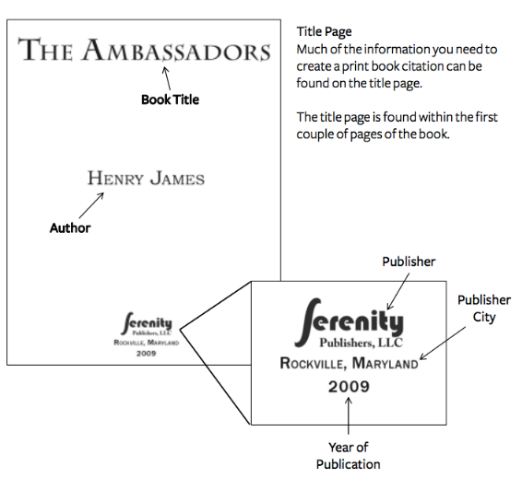

Example:
James, Henry. The Ambassadors. Rockville: Serenity, 2009. Print.

FOR WORKS CITED PAGE: CITING AN E-BOOK:

Last name, First name. Book Title. Edition. City of Publication: Publisher, Year of Publication. E-book.

FOR WORKS CITED PAGE: CITING A BOOK WITHOUT AN AUTHOR:

Book Title. Edition. City of Publication: Publisher, Year of Publication. Medium.

**Medium means whether it’s a print or e-book.
FOR WORKS CITED PAGE: CITING A WEBSITE WITH AN AUTHOR:
:
Last, First M. “Article Title.” Website Title. Date Month Year Published. Link to website.
Date Month Year Accessed.
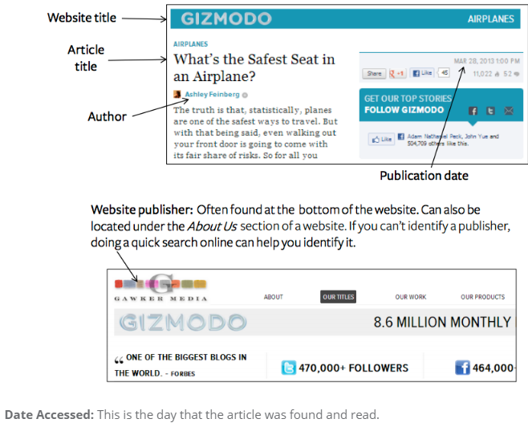

Example:
Feinberg, Ashley. “What’s the Safest Seat in an Airplane?” Gizmodo. 28 Mar. 2013.
https://gizmodo.com/whats-the-safest-seat-in-an-airplane-5992761. 30 Mar. 2017.

FOR WORKS CITED PAGE: CITING A WEBSITE WITHOUT AN AUTHOR:

“Article Title.” Website Title. Website Publisher, Date Month Year Published. Link to website. Date
Month Year Accessed.

Using In-Text/Parenthetical Citations

- Books: (Author page#)
  - Example: (Fitzgerald 15)
- Website: (Author). If no author, (“Title of article”) or (Website Title), depending on which appears first in the full citation
  - Example: (Getrajdman) or (“The Life and Times of a Teacher”) or (TeacherWeb)

General Things

- Period comes AFTER in-text citation at the END OF THE SENTENCE.
  - Example: Nick Carraway’s father tells him that “not all people were born with the same advantages [he] has,” showing that his father wants him to be tolerant of other people (Fitzgerald 7).
- When quoting four lines or more (block quotes), indent every line you are quoting by one inch (or 10 spaces) and do not use quotes.
  - Side note: with a quote this long, consider paraphrasing or only using part of the quote instead of the entire thing to minimize your plagiarism count.
- Organize your Works Cited page alphabetically.
- Cite only the sources that are used within your paper.
- If a citation runs onto more than one line, use a hanging indent (indent all lines following the first).

