Name: ___________________________________ Period: ______ Date: __________________

U.S. History II - April SGO Assessment
Directions: Analyze the following sources regarding the 1960 presidential campaign between Democrat John F. Kennedy and Republican Richard M. Nixon. Answer the questions after each Document in full sentences, then answer the Opinion question at the end in one full paragraph. Cite examples from the Documents where applicable.

Opinion Question
As you read Documents A-C, consider the following question:
-If you were voting in the 1960 presidential election, who would you vote for and why? Justify your answer with examples from the Documents.

Document A
Campaign Commercials
lodius2dbq.weebly.com
Open the above URL in your browser and view the videos titled “JFK Campaign Jingle Election Ad” and “Nixon 1960 Campaign Ad.” After viewing the commercials for each of the candidates, answer the following questions:
- What was the intended purpose of each commercial?
- Which candidate provides more factual information? Justify your answer with evidence from one of the videos.
- Which of the two commercials would appeal to the average American? Explain your reasoning.

Document C
Website Article
THE KENNEDY-NIXON PRESIDENTIAL DEBATES, 1960
On 26 September 1960, 70 million U.S. viewers tuned in to watch Senator John Kennedy of Massachusetts and Vice President Richard Nixon in the first-ever televised presidential debate. It was the first of four televised "Great Debates" between Kennedy and Nixon. The first debate centered on domestic issues. The high point of the second debate, on 7 October, was disagreement over U.S. involvement in two small islands off the coast of China, and on 13 October, Nixon and Kennedy continued this dispute. On 21 October, the final debate, the candidates focused on American relations with Cuba.
The Great Debates marked television's grand entrance into presidential politics. They afforded the first real opportunity for voters to see their candidates in competition, and the visual contrast was dramatic. In August, Nixon had seriously injured his knee and spent two weeks in the hospital. By the time of the first debate he was still twenty pounds underweight, his pallor still poor. He arrived at the debate in an ill-fitting shirt, and refused make-up to improve his color and lighten his perpetual "5:00 o'clock shadow." Kennedy, by contrast, had spent early September campaigning in California. He was tan and confident and well-rested. "I had never seen him looking so fit," Nixon later wrote.
In substance, the candidates were much more evenly matched. Indeed, those who heard the first debate on the radio pronounced Nixon the winner. But the 70 million who watched television saw a candidate still sickly and obviously discomforted by Kennedy's smooth delivery and charisma. Those television viewers focused on what they saw, not what they heard. Studies of the audience indicated that, among television viewers, Kennedy was perceived the winner of the first debate by a very large margin.

Answer the following questions after reading the above article:
- What were the central issues of the 1960 presidential debates?
- Compare the perceived outcome of the election debates in terms of the radio and television audiences. Use examples from the article to support your answer.
- Why do you think televised debates have become such an important part of a modern presidential election?

Document B
Campaign Buttons/Posters
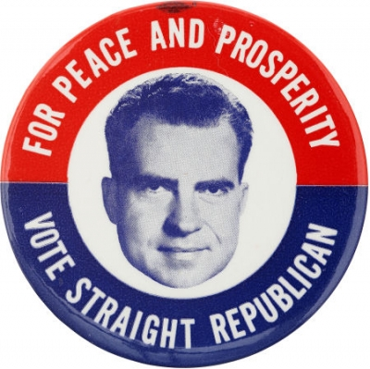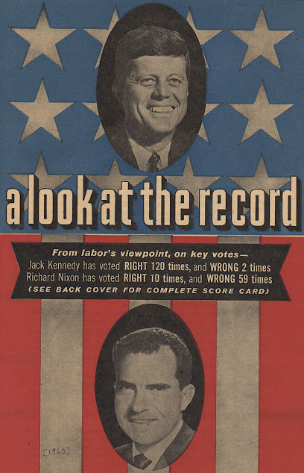
Campaign Button 1 Poster 1

Observe the pictures above and answer the following questions:
- Which candidate is Campaign Button 1 supporting? Which candidate is Poster 1 supporting? What makes this evident for each?
- What message is each of the campaign pieces trying to show?
- Which picture is more effective at appealing to a larger audience? Why do you think so? (Explain your reasoning.)

Standards Used
6.1.12.A.12.A | Analyze ideological differences and other factors that contributed to the Cold War and to United States involvement in conflicts intended to contain communism including the Korean War the Cuban Missile Crisis and the Vietnam War.

09-10.RH.01 | Cite specific textual evidence to support analysis of primary and secondary sources attending to such features as the date and origin of the information.

09-10.RH.04 | Determine the meaning of words and phrases as they are used in a text including vocabulary describing political social or economic aspects of historysocial studies.

09-10.RH.05 | Analyze how a text uses structure to emphasize key points or advance an explanation or analysis.

09-10.RH.06 | Compare the point of view of two or more authors for how they treat the same or similar topics including which details they include and emphasize in their respective accounts.

11-12.RH.07 | Integrate and evaluate multiple sources of information presented in diverse formats and media (e.g. visually quantitatively as well as in words) in order to address a question or solve a problem.

