DBQ: Supplemental Packet

**Document A: Proclamation of 1763**

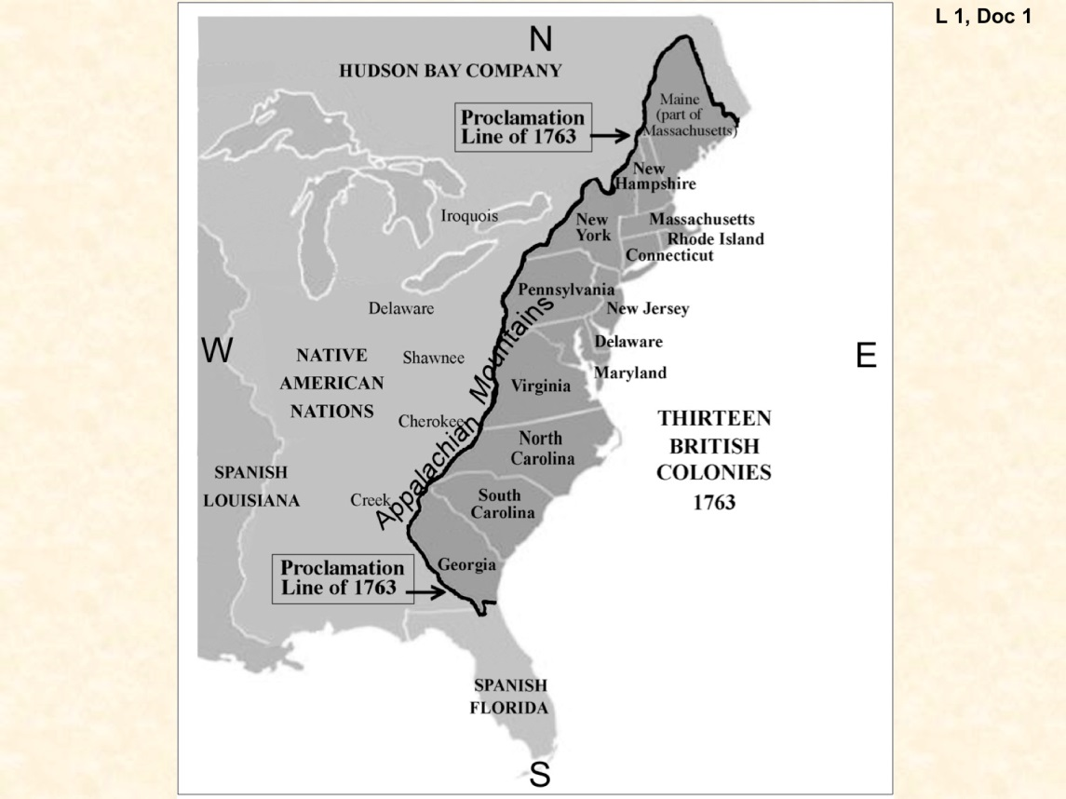

**Document B: Imports from Britain 1764-1774**



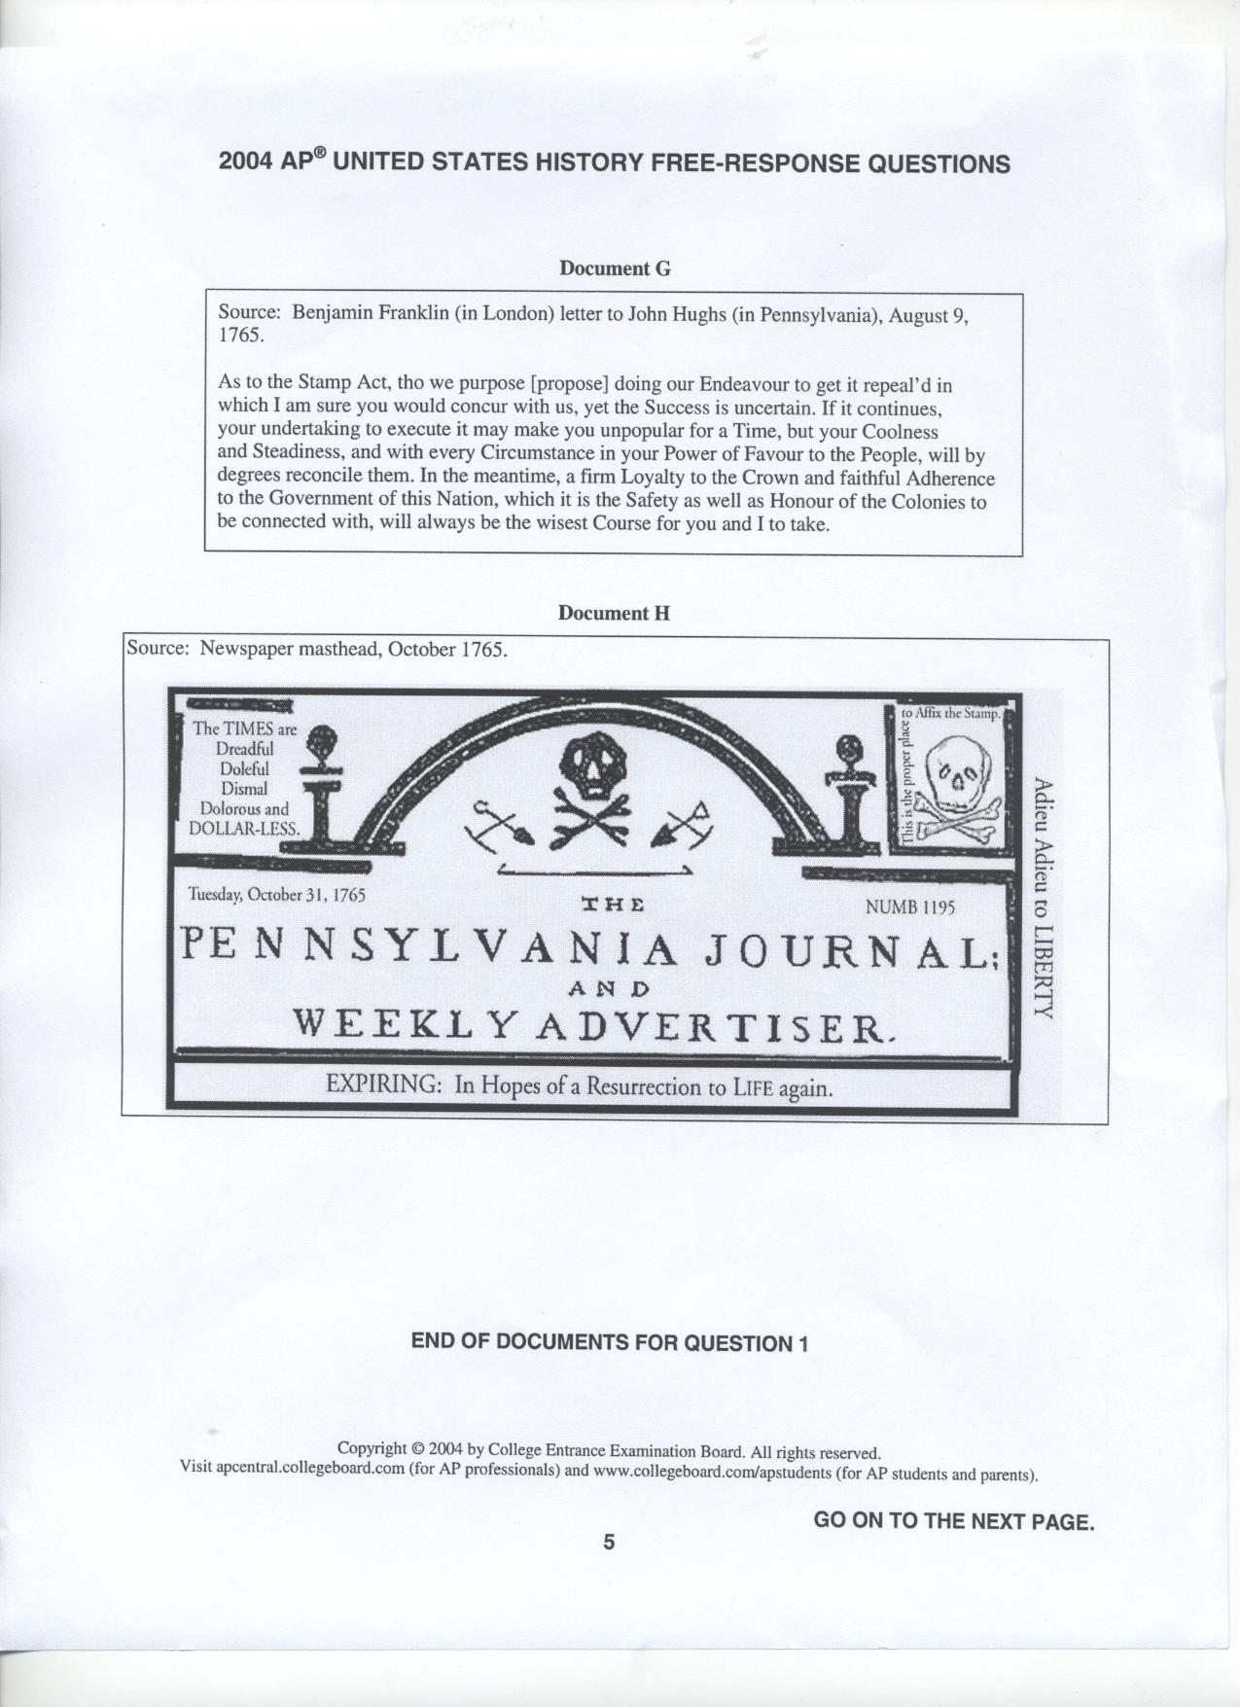**Document C: Stamp Act Masthead**

**Document D: Grenville’s Quote**

That this kingdom has the sovereign, the supreme legislative power over America, is granted. It cannot be denied; and taxation is a part of that sovereign power. It is one branch of the legislation. . . . Protection and obedience are reciprocal. Great Britain protects America, America is bound to yield [give] obedience. If not, tell me when the Americans were emancipated? When they want the protection of this kingdom, they are always ready to ask it. That protection has always been afforded them in the most full and ample manner. The nation has run itself into an immense debt to give them this protection; and now they are called upon to contribute a small share to the public expense.

—George Grenville, Prime Minister to Parliament (January 14, 1766)

**Document E: Washington’s Rebuttal**

If I was in any doubt, as to the right which the Parliament of Great Britain had to tax us without our consent, I should most heartily coincide with you in opinion, that to petition, and petition only, is the proper method to apply for relief; because we should then be asking a favor, and not claiming a right, which, by the law of nature and our constitution, we are, in my opinion, indubitably entitled to. I should even think it criminal to go farther than this, under such an idea; but none such I have. I think the Parliament of Great Britain hath no more right to put their hands into my pockets, without my consent, than I have to put my hands into yours for money; and this being already urged to them in a firm, but decent manner, by all the colonies, what reason is there to expect any thing from their justice?

—George Washington, letter to Bryan Fairfax (July 20, 1774)

**Document F: Declaration of Independence**

When in the Course of human events, it becomes necessary for one people to dissolve the political bands which have connected them with another, and to assume among the powers of the earth, the separate and equal station to which the Laws of Nature and of Nature's God entitle them, a decent respect to the opinions of mankind requires that they should declare the causes which impel them to the separation.

We hold these truths to be self-evident, that all men are created equal, that they are endowed by their Creator with certain unalienable Rights, that among these are Life, Liberty and the pursuit of Happiness.--That to secure these rights, Governments are instituted among Men, deriving their just powers from the consent of the governed, --That whenever any Form of Government becomes destructive of these ends, it is the Right of the People to alter or to abolish it, and to institute new Government, laying its foundation on such principles and organizing its powers in such form, as to them shall seem most likely to effect their Safety and Happiness. Prudence, indeed, will dictate that Governments long established should not be changed for light and transient causes; and accordingly all experience hath shewn, that mankind are more disposed to suffer, while evils are sufferable, than to right themselves by abolishing the forms to which they are accustomed. But when a long train of abuses and usurpations, pursuing invariably the same Object evinces a design to reduce them under absolute Despotism, it is their right, it is their duty, to throw off such Government, and to provide new Guards for their future security.--Such has been the patient sufferance of these Colonies; and such is now the necessity which constrains them to alter their former Systems of Government. The history of the present King of Great Britain is a history of repeated injuries and usurpations, all having in direct object the establishment of an absolute Tyranny over these States. To prove this, let Facts be submitted to a candid world.

He has refused his Assent to Laws, the most wholesome and necessary for the public good.  
He has forbidden his Governors to pass Laws of immediate and pressing importance, unless suspended in their operation till his Assent should be obtained; and when so suspended, he has utterly neglected to attend to them.  
He has refused to pass other Laws for the accommodation of large districts of people, unless those people would relinquish the right of Representation in the Legislature, a right inestimable to them and formidable to tyrants only.   
He has called together legislative bodies at places unusual, uncomfortable, and distant from the depository of their public Records, for the sole purpose of fatiguing them into compliance with his measures.   
He has dissolved Representative Houses repeatedly, for opposing with manly firmness his invasions on the rights of the people.  
He has obstructed the Administration of Justice, by refusing his Assent to Laws for establishing Judiciary powers.  
He has combined with others to subject us to a jurisdiction foreign to our constitution, and unacknowledged by our laws; giving his Assent to their Acts of pretended Legislation:  
For taking away our Charters, abolishing our most valuable Laws, and altering fundamentally the Forms of our Governments:  
For suspending our own Legislatures, and declaring themselves invested with power to legislate for us in all cases whatsoever.  
He has abdicated Government here, by declaring us out of his Protection and waging War against us.

In every stage of these Oppressions We have Petitioned for Redress in the most humble terms: Our repeated Petitions have been answered only by repeated injury. A Prince whose character is thus marked by every act which may define a Tyrant, is unfit to be the ruler of a free people.

Nor have We been wanting in attentions to our Brittish brethren. We have warned them from time to time of attempts by their legislature to extend an unwarrantable jurisdiction over us. We have reminded them of the circumstances of our emigration and settlement here. We have appealed to their native justice and magnanimity, and we have conjured them by the ties of our common kindred to disavow these usurpations, which, would inevitably interrupt our connections and correspondence. They too have been deaf to the voice of justice and of consanguinity. We must, therefore, acquiesce in the necessity, which denounces our Separation, and hold them, as we hold the rest of mankind, Enemies in War, in Peace Friends.

We, therefore, the Representatives of the united States of America, in General Congress, Assembled, appealing to the Supreme Judge of the world for the rectitude of our intentions, do, in the Name, and by Authority of the good People of these Colonies, solemnly publish and declare, That these United Colonies are, and of Right ought to be Free and Independent States; that they are Absolved from all Allegiance to the British Crown, and that all political connection between them and the State of Great Britain, is and ought to be totally dissolved; and that as Free and Independent States, they have full Power to levy War, conclude Peace, contract Alliances, establish Commerce, and to do all other Acts and Things which Independent States may of right do. And for the support of this Declaration, with a firm reliance on the protection of divine Providence, we mutually pledge to each other our Lives, our Fortunes and our sacred Honor.

**Document G: Articles of Confederation**

*Historical Context*: Following the American Revolution, the newly created United States was in need of a government. The first attempt at a national government was known as the Articles of Confederation. Although t was only short-lived, the Articles represented an important step in the development of America’s government.

The ARTICLES of CONFEDERATION and PERPETUAL UNION

Between The States Of

New Hampshire, Massachusetts-bay Rhode Island and Providence Plantations, Connecticut, New York, New Jersey, Pennsylvania, Delaware, Maryland, Virginia, North Carolina, South Carolina and Georgia.

ARTICLE I The Stile of this Confederacy shall be "The United States of America"

ARTICLE II Each state retains its sovereignty, freedom, and independence, and every power, jurisdiction, and right, which is not by this Confederation expressly delegated to the United States, in Congress assembled.