US History I
SGO Assessment 2: Sectionalism in America
Standards:
6.1A Grade 12 CPI 03.H, Analyze the various rationales provided as a justification for slavery.
6.1B Grade 12 CPI 03.A, Assess the impact of Western settlement on the expansion of United States political boundaries.
6.1C Grade 12 CPI 03.A, Analyze how technological developments transformed the economy, created international markets, and affected the environment in New Jersey and the nation.
6.1C Grade 12 CPI 03.B, Relate the wealth of natural resources to the economic development of the United States and to the quality of life of individuals.
6.1D Grade 12 CPI 03.A, Determine how expansion created opportunities for some and hardships for others by considering multiple perspectives.
6.1D Grade 12 CPI 03.C, Assess how states' rights and sectional interests influenced party politics and shaped national policies.
09-10.RH.02, Determine the central ideas or information of a primary or secondary source; provide an accurate summary of how key events or ideas develop over the course of the text.
09-10.RH.03, Analyze in detail a series of events described in a text; determine whether earlier events caused later ones or simply preceded them.
09-10.RH.04, Determine the meaning of words and phrases as they are used in a text, including vocabulary describing political, social, or economic aspects of history/social studies.
09-10.RH.09, Compare and contrast treatments of the same topic in several primary and secondary sources.

Part I: The Missouri Compromise

Document A: Summary of the Missouri Compromise
A serious argument over slavery took place in Congress when Missouri asked to be admitted to the Union in 1819. Missouri was a territory making up part of the Louisiana Purchase. Many settlers in Missouri came from southern states. Slavery was allowed in Missouri.
At that time, there were exactly the same number of "free" states (states that did not allow slavery) as there were "slave" states (states that did allow slavery). This meant that there was a balance of power in the United States Senate, where all states are represented equally. The "free" states had a majority in the House of Representatives because the northern states had a larger population than the southern states.
When Missouri's request to be admitted reached Congress, a northern Congressmen proposed that it should be admitted only if it promised to free its slaves. Southerners in Congress angrily replied that the North had no right to require this.
In December 1819, Maine also asked to be admitted to the Union. The House of Representatives was ready to approve Maine's request. There was no slavery in Maine. However, at first the Senate would not allow Maine to enter the Union. Southern senators refused to admit Maine as a free state unless the northern senators would agree to admit Missouri as a slave state.
In 1820 Henry Clay of Kentucky helped arrange a compromise that allowed both Maine and Missouri to enter the Union. By means of the Missouri Compromise, as the new agreement was called, several laws were passed. Congress admitted Maine as a free state and Missouri as a slave state. Slavery had now spread to one more state.
At the same time, Congress drew a line westward across what was left of the Louisiana Purchase. This line, set at 36° 30' North latitude, divided free and slave territory. In the future, any states formed north of the line would be (closed to slavery) free states. Any new states formed south of the line would be (open to slavery) slave states.
- Based on Document A, which of the following statements is true?
  - Prior to the Missouri compromise, there were an equal number of free and slave states.
  - Originally Maine wanted to enter the Union as a slave state.
  - Most Southerners in Congress were against slavery spreading to any new states.
  - There was a balance of power in the House of Representatives, but the South had more members in the US Senate.
  - All of the above.

- Based on information from Document A, what issues likely prevented Missouri and Maine from entering the Union as new states?
  - If only one state entered the Union, it would create an uneven number of free states and slave states.
  - The House of Representative initially approved Maine entering as a free state, but the Senate refused.
  - Northern Congressmen demanded that Missouri enter as a free state, which angered Southern Congressmen.
  - All of the above.
  - None of the above.

- As explained in Document A, Henry Clay proposed a solution called the Missouri Compromise. According to the reading, what happened as a result of the Missouri Compromise?
  - Missouri entered the Union as a free state, Maine entered the Union as a slave state.
  - Missouri would wait until a later time to apply for statehood.
  - Maine entered the Union as a free state, Missouri entered the Union as a slave state.
  - All of the above.
  - None of the above.

- The line set at 36° 30’, called the Missouri Compromise Line, divided free territory and slave territory. According to information from Document A, in what ways did it divide free territory from slave territory?
  - Existing states south of the Missouri Compromise Line must immediately free all their slaves.
  - Any new states north of the Missouri Compromise Line would be closed to slavery.
  - No new states could be formed north of the Missouri Compromise Line.
  - Any new states south of the Missouri Compromise Line would be closed to slavery.
  - All of the above.

Document B: Map of the Missouri Compromise
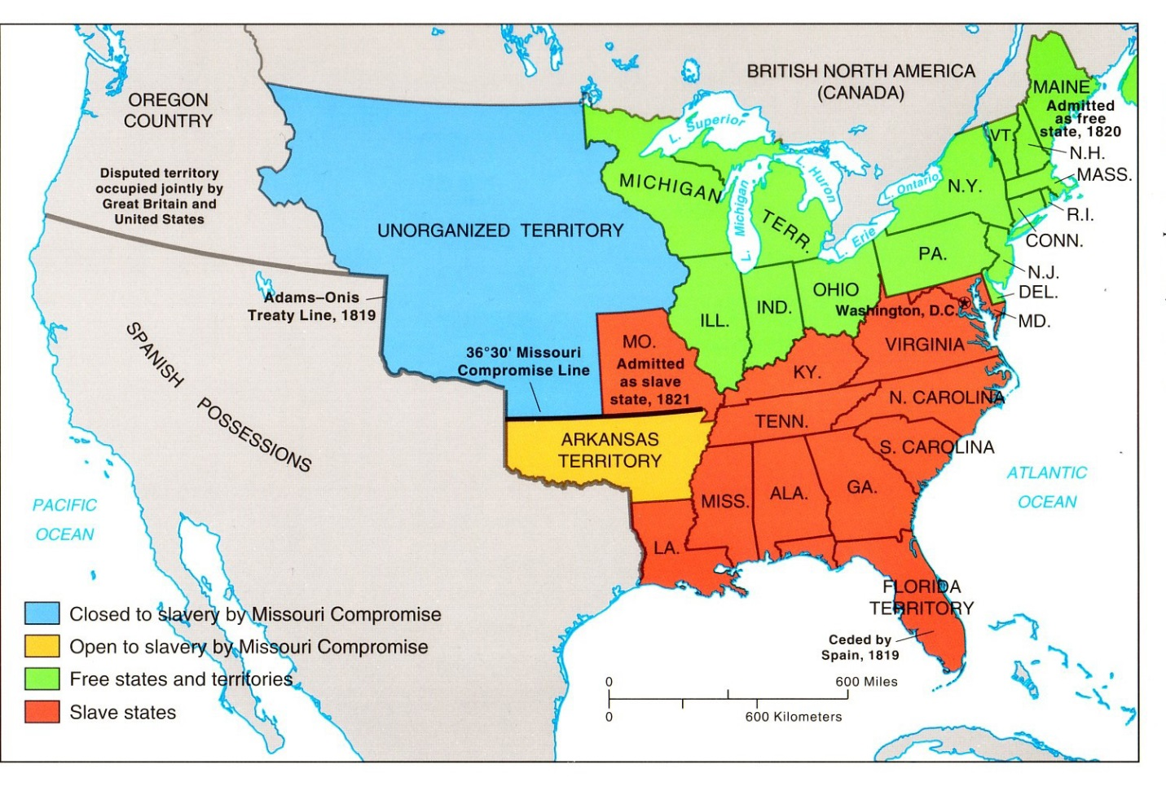
- According to Document B, which of the following states was opposed to slavery in 1820 and had made it illegal to own slaves?
  - Pennsylvania
  - Virginia
  - South Carolina
  - Maryland
  - None of the above.

- Which of the following states openly practiced owning slaves and promoted slavery in 1820, as shown on Document B?
  - Ohio
  - New York
  - Georgia
  - Illinois
  - None of the above.

- Based on information from Document A and Document B, which of the following statements is true?
  - Missouri borders only slave states.
  - Any new state south of Missouri’s southern border would be a free state.
  - Most of the Unorganized Territory is open to slavery.
  - Any new state north of Missouri’s southern border would be a free state.
  - None of the above.

Part II: Regional Differences

Document C: North vs. South
The northern and southern states were developing differently. The South was sending its cotton north to factories and for shipment across the Atlantic – mainly to Britain. And growing more cotton and less food, the South was importing food. Northerners were investing profits from their industry in advances in machinery for all kinds of commercial enterprises, including farmers investing in better tools.
In 1793, Eli Whitney, a Yale College graduate in Massachusetts, had developed a machine (the cotton ‘gin) to more easily and efficiently separate cottonseeds from cotton fibers (which is the part of cotton used for making cloth and other products). The availability of his cotton ‘gin helped cotton become the South's greatest industry by 1820. Production of cotton doubled between 1820 and 1830. People in the southern states were putting their capital (money) into more land and more slaves and into cotton production; Southerners were investing in slaves rather than labor-saving machinery.
Southern plantation owners had less money to invest and were usually in debt to northern bankers. Many who were not plantation owners were interested in buying land and retiring on a small plantation.
Slavery was not suitable for the small family farms or for manufacturing enterprises of the North. By 1820 half of the northern states had outlawed slavery, while in the South there were 52 slaves for every 100 whites.

Document D: Differences between North and South Table

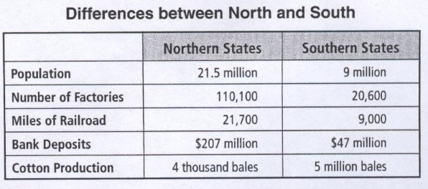

Based on Documents C & D, please respond to the following questions.

- Which of the following statements is most true?
  - The cotton industry led to the Southern States building nearly as many factories as there were in the North.
  - Although cotton was the Southern States’ top industry, the Southern States still had less money than the Northern States.
  - The cotton ‘gin decreased the need for slave labor.
  - Both the Northern States and the Southern states produced and exported roughly the same amount of cotton.
  - None of the above.

- Which statement is most true regarding slavery in America?
  - The cotton ‘gin contributed to a rise in the number of slaves purchased to work on plantations.
  - Although most Northern States did not directly purchase slaves, Southern slave labor still provided most of the cotton in northern factories.
  - Most Southerners would rather spend money on more slaves than investing in railroads and factories.
  - All of the above.
  - None of the above.

- Which of the following may be a reason why there was sectional conflict between Northerners and Southerners?
  - Northerners refused to purchase, produce, or export anything associated with slave labor.
  - The South was overpopulated, leading to Southerners sneaking up north and taking away factory jobs.
  - Many Southern farmers and plantation owners owed money to banks in the north, placing them in debt.
  - The cotton ‘gin forced Southern plantation owners to sell off most of their slaves.
  - All of the above.

Document E: Candidates for the Election of 1824

Presidential Candidates for the 1824 Election
Henry Clay | From Kentucky  Represented the western states  Favored national banks  Favored protective tariff  Supported nationwide internal improvements
Andrew Jackson | From Tennessee  Represented the western states  Not specific on issues  Centered campaign on his personal heroism in the Battle of New Orleans
William Crawford | From Georgia  Represented the southern states  Emphasized state’s rights  Believed in strict interpretation of constitution
John Quincy Adams | From Massachusetts  Represented New England states  Supported nationwide internal improvements  Did not favor protective tariffs

Document F: Election of 1824 Results

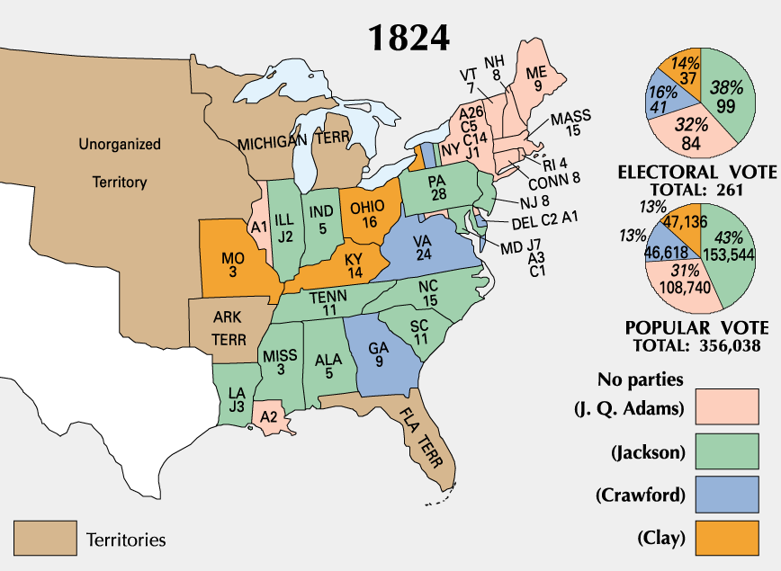

Based on Documents E and F, please indicate if the following statements are True or False.

- Each candidate except John Quincy Adams won the election in his home state.
- Andrew Jackson did not declare a position on any of the specific issues of the day, which likely contributed to him winning the majority of electoral votes and popular votes.
- Each state voted for only one candidate; no states split their electoral votes among different candidates.
- No northern states (north of Missouri) voted for Southern candidates.
- Although both Jackson and Clay represented the western states, Jackson had more support around the entire nation.

Essay:

Topic
Based on information from all the provided documents, assess how sectional interests influenced political decisions.

Questions
What sectional differences existed before the Missouri Compromise?
What sectional differences existed after the Missouri Compromise?
How did these sectional differences affect America?

