Guilded Age- Progressivism
US History II Mr. Tuttle

michael.tuttle@lodi.k12.nj.us
NO ELECTRONIC DEVICES MAY BE USED DURING THIS TEST
Standards:
- 6.1A Grade 12 CPI 06.A
Evaluate the effectiveness of Progressive reforms in preventing unfair business practices and political corruption and in promoting social justice.
- 6.1A Grade 12 CPI 06.B
Evaluate the ways in which women organized to promote government policies (i.e., abolition, women’s suffrage, and the temperance movement) designed to address injustice, inequality, workplace safety, and immorality.
- 6.1A Grade 12 CPI 10.C
Evaluate the short- and long-term impact of the expanded role of government on economic policy, capitalism, and society.
- 6.1A Grade 12 CPI 14.C
Assess the merit and effectiveness of recent legislation in addressing the health, welfare, and citizenship status of individuals and groups.
5. 11-12.L.04.A
Use context (e.g., the overall meaning of a sentence, paragraph, or text; a word's position or function in a sentence) as a clue to the meaning of a word or phrase.
6. 11-12.RH.06
Evaluate authors' differing points of view on the same historical event or issue by assessing the authors' claims, reasoning, and evidence.
7. 11-12.RH.08
Evaluate an author's premises, claims, and evidence by corroborating or challenging them with other information.

Multiple Choice

- What did progressives think needed to play a more aggressive role in solving societies problems?
  - the government
  - the churches
  - social welfare organizations
  - big business
  - all of the above

- Progressives believed all of the following about government except:

it should be more accountable to its citizens
  - it should curb the power and influence of wealthy interests
  - it should be given expanded powers so that it could become more active in improving the lives of its citizens.
  - it should allow the “invisible hand” of economics to regulate trade.
  - it should become more efficient and less corrupt.

- People who alert the public to wrongdoing in politics and business are called...
  - scalawags C. socialists E. paparazzi
  - muckrakers D. tarbells

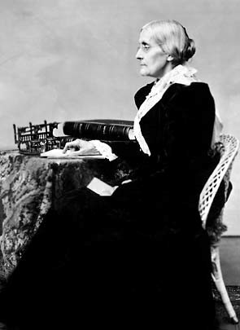
"The true republic: men, their rights and nothing more; women, their rights and nothing less."

- What was Susan B. Anthony arguing for when she said this?
  - prohibition
  - abolition
  - women’s suffrage
  - workplace safety
  - the end of Jim Crow

- The meeting in 1905 that included WEB Dubois and other African Americans to demand full political rights eventually resulted in the formation of
  - the progressive party
  - the NAACP
  - Federal Trade Commission
  - Tuskegee University
  - Colored Farmer’s Alliance

- Teddy Roosevelt became known as a “Trust Buster” because he used the law to regulate
  - monopolies C. foreign banks E. progressives
  - board games D. the environment

- Upton Sinclair wrote a book called the jungle which described terrible conditions in
  - the meat industry
  - the sugar industry
  - immigration control
  - city sanitation
  - American schools

- Jacob Riis took..
  - the life of President McKinley
  - candy from a small child
  - photographs of city dwellers
  - …over Standard Oil from the Rockefellers
  - Ida Tarbell’s breath away

- In the election of 1912, Roosevelt became the candidate for which political party?
  - Republican
  - Democratic
  - Bull-Moose
  - Labor
  - United We Stand

- The Temperance Movement wanted to make which product illegal?
  - tobacco
  - alcohol
  - firearms
  - prostitution
  - gambling

- which is the only President to earn a Ph.D. in Political Science
  - Roosevelt
  - Taft
  - Wilson
  - McKinley
  - Hoover

- Which President had trouble getting out of the white house bathtub?
  - McKinley
  - Roosevelt
  - Taft
  - Wilson
  - Harding

- Which was Wilson’s 1916 Campaign slogan?
  - Bring the Boys Home
  - He Kept Us Out Of War
  - A Chicken in Every Pot
  - The Square Deal
  - Yes We Can

- Wilson wanted to
  - Lower Tariffs
  - Strengthen the banks by forming the Federal Reserve System
  - Keep the US Neutral
  - get rid of taxes on “Necessary Items”
  - All of the Above

- Theodore Roosevelt became President
  - by defeating William Jennings Bryan
  - by defeating McKinley
  - when McKinley died of influenza after giving a long speech
  - when McKinley was assassinated
  - when McKinley was impeached

- How did the Muckrakers help spark the Progressive Movement
  - They uncovered corruption in many areas.
  - They focused on stopping Anti-Federalists
  - They sold newspapers door to door.
  - They forced the Senate to approve treaties.
  - They used the press to get the US into the war.

- What was the impact of the 17th amendment?
  - Equal rights could not be abridged on account of sexual orientation.
  - Senators would now be directly elected by the people.
  - The Vice-President would be chosen by the President.
  - The right to bear arms would be limited.
  - Children must attend School until the age of sixteen.

MATCHING

youngest President
- favored big business
- promised fair and equal treatment for all
- preservation of natural resources
- Progressive Party

- conservation
- Theodore Roosevelt
- Bull Moose Party
- William McKinley
- square deal

USE THE DOCUMENT PROVIDED TO ANSWER THE QUESTIONS

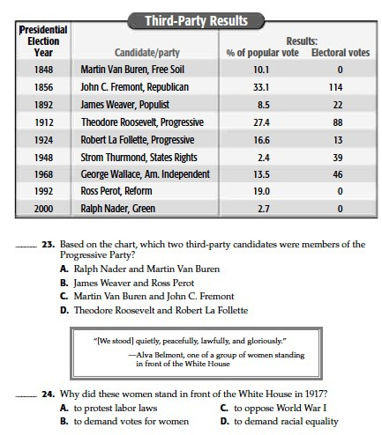

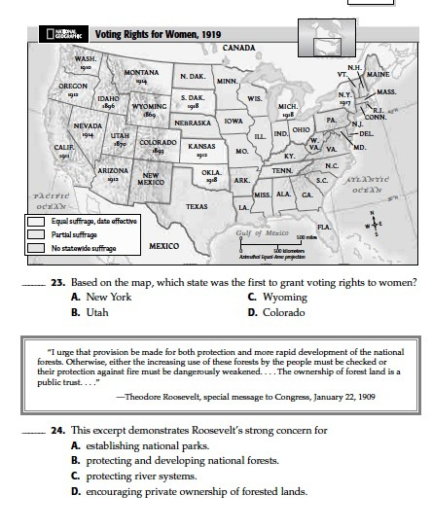
Lodi, NJ 07644

25

26

Lodi, NJ 07644

27. What term refers to the time period 1890-1910, when the US was outwardly successful yet had deep social problems?
a. The Iron Age
b. The Gilded Age
c. The Age of innocence
d. The Age of Consent
e. The Age of Aquarius

28. Andrew Carnegie’s Idea that successful people owed a debt to society…
a. The Social Gospel
b. The American Gospel
c. The Gospel of Wealth
d. The Gospel of Minimalism
e. The Gospel of Andrew

29. In the aftermath of the 1911 Triangle Shirtwaist fire in New York City,
A. New York State barred factories from employing women under the age of sixteen.
B. factories taller than ten stories could only use the upper floors for storage of materials.
C. few true reforms of industry were made.
D. strict regulations were imposed on factory owners.
E. Tammany Democrats attempted to thwart the New York State commission examining the fire.

30. The Pendleton Act was about
a. civil service reform
b. voter rights
c. direct election of Senators
d. labor unions
e. gun control

31. A contract that forbids a worker to join a labor union is a…

a. golden handcuffs
b. fine print
c. grey matter agreement
d. black ball clause
e. yellow dog contract

32 During the progressive era, significant voting rights for women were first won in
A. the mid-Atlantic states.
B. the South.
C. New England.
D. the Midwest.
E. the Far West.

33. Which was NOT a cause of industrial growth in the late 1800’s?
a. cheap labor
b. abundant natural resources
c. a superior educational system
d. technological advances
e. a government that was friendly to industry

34. The gold Standard was criticized in the “Cross of Gold” speech by
a. William Henry Taft
b. William Jennings Bryan
c. William Jefferson Clinton
d. William Robert Thornton
e. William McKinley

35. A general vote by the electorate on a single political question that has been referred to them for a direct decision.
a. Hanging Chad
b. Referendum
c. Etymology
d. Petition
e. Initiative

36.The Jungle caused people to pressure Congress to pass this.
a. The stamp Act
b. The Securities and Exchange Act
c. The Sullivan Act
d. The Meat Inspection Act
e. The Sherman Antitrust Act

37. – 41 Put the Presidents in Order
a. Taft
b. Cleveland
c. Roosevelt
d. McKinley
e. Wilson

42. Reconstruction ended in what year?
a. 1877
b. 1888
c. 1902
d. 1919
e. 2017

43. Who won the election of 1876?
a. Tilden
b. Harrison
c. Taft
d. Grant
e. This is a trick question

44. William Howard Taft
a. Got stuck in the Tub
b. Had a stuffed Possum names for him
c. Sued US Steel
d. Suffered from Depression
e. All of the above

45. At the turn of the twentieth century, the leaders of the settlement house movement

A. eventually saw their ideas and institutions take hold in England.
B. generally expressed moral disapproval of the behavior of immigrants.
C. thought assimilation robbed immigrants of the best parts of their culture.
D. were generally first-generation immigrants who helped second-generation immigrants.
E. directed their attention to improving urban living conditions.

46. In 1904, Ida Tarbell published a highly critical study on
A. the Carnegie Steel Company.
B. child industrial labor.
C. urban “boss rule.”
D. the Standard Oil trust.
E. Congress.

47. During the progressive era, W. E. B. Du Bois asserted all of the following EXCEPT that
A. Booker T. Washington’s ideas were unnecessarily limiting to blacks.
B. talented blacks should accept nothing less than a full university education.
C. blacks should fight for immediate civil rights.
D. seeking legal challenges to civil injustice through white-dominated courts was a pointless exercise.
E. blacks should aspire to the professions.

48. During the progressive era, the acknowledged leader of American socialism was
A. Lincoln Steffens.
B. William Haywood.
C. Florence Kelley.
D. Eugene V. Debs.
E. A. Mitchell Palmer.

49. The Sierra Club was founded by
A. Gifford Pinchot.
B. Theodore Roosevelt.
C. John Muir.
D. Richard Ballinger.
E. Louis Glavis.

50. As president, William Howard Taft
A. angered many conservatives with his activism.
B. generally pleased progressives.
C. managed to match Roosevelt’s personal dynamism.
D. angered many conservatives with his activism, but generally pleased progressives.
E. None of these answers is correct.

