United States History I

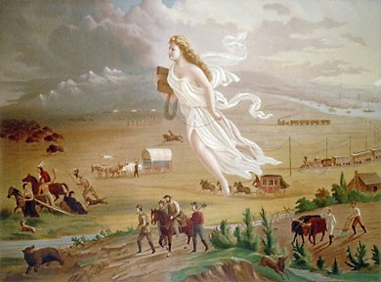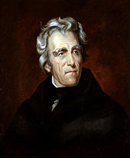

Westward Movement, Jacksonian America,
Economic Development, & Sectionalism

Objective: Summarize the impact of the westward movement on nationalism and democracy, including the expansion of the franchise, the displacement of Native Americans from the southeast and conflicts over states’ rights and federal power during the era of Jacksonian democracy as the result of major land acquisitions such as the Louisiana Purchase, the Oregon Treaty, and the Mexican Cession.

The Louisiana Purchase

1803 – Jefferson purchased Louisiana from ___________________. He sent Lewis and Clark to explore the Purchase (WIN) and to find a ________________ Passage (FAIL).
Jefferson had doubts as to whether the _________________ permitted the federal government to purchase land, but he did it anyway.
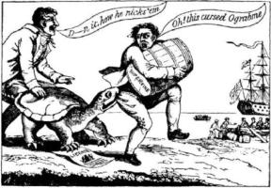
The War of 1812

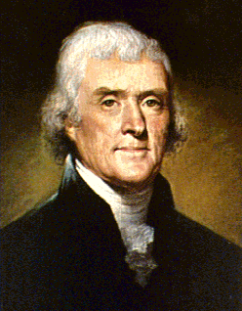
The __________________ Act (1807)
Economic Coercion [INNEFECTIVE]
THIS CURSED OGRABME!!!
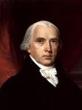
Madison’s War Message

- Impressment of Sailors
- Cutting off American Trade
- Arming ____________ ______________ on the western frontier

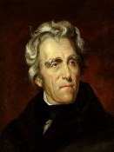
After the War of 1812, the U.S. continued to expand to the West, ushering in an era
of democracy and the common man. Andrew ________________, the hero of the Battle of New Orleans, was elected president in 1828. Jackson typified this era of the common man.

Indian Removal
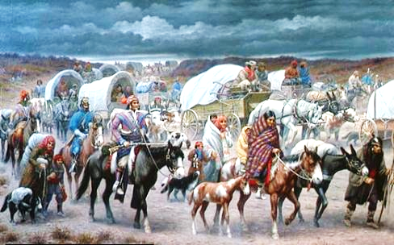
Trail of __________________: Jackson approved of moving Native American tribes, such as the Cherokee, from the Southeast to the Indian Territory (Oklahoma).
(Jackson had spent much of his military career fighting Indians.)

KEY TERRITORIAL ACQUISITIONS

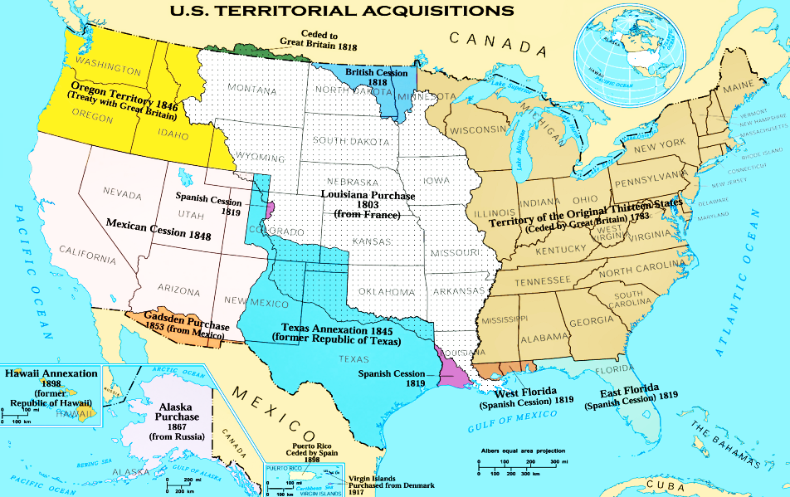 | 1803
 | 1845
 | 1846
 | 1848

Objective Explain how the Monroe Doctrine and the concept of Manifest Destiny affected the United States’ relationships with foreign powers, including the role of the United States in the Texan Revolution and the Mexican War.

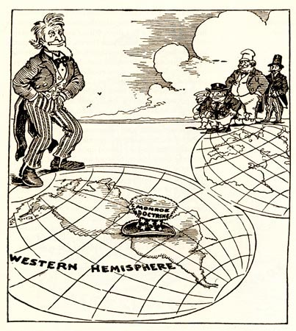
Monroe Doctrine (1823)

U.S. to Europe:
NO NEW _________________________

The Monroe Doctrine had little impact on European Powers at the time, but it is significant for U.S. foreign policy because it provided justification for later U.S. presidents (e.g., TR, Taft, and Wilson) to intervene in Latin America in the 20th century.

Manifest Destiny Sea to Shining Sea…

Texas and the Mexican War (1835-1848)

Texas, a Mexican state, attracted many American colonists from the Southern United States. In 1835, after disputes with the Mexican government about dictatorship and slavery, Texas declared independence.

1836: Texas asks to be annexed as a U.S. state.

The U.S. ( accepts / refuses ) Reasons: 1. _________________________
2. _________________________

1844 Presidential Campaign: Texas annexation an issue

James K. ___________________ wins. Americans supported annexation.

1845: U.S. annexes Texas = War with ____________________________

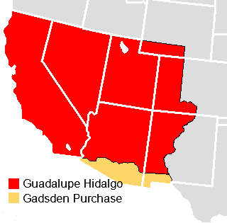
AMERICA WINS BIG!!!

1848: Mexican ________________________
US gets land from Mexico

States included: ___________________________________

The United States and Mexico became ( allies / adversaries ) as a result of the Mexican War.

Meanwhile, the U.S. compromised with Britain on the border of ____________________________.

Objective Compare the economic development in different regions (the South, the North, and the West) of the United States during the early nineteenth century, including ways that economic policy contributed to political controversies.

Antebellum means “_______________ _____ ______________.” In U.S. History, antebellum describes the period from 18___ to 18___, between the ________________ Compromise and the _____________ _________.

SECTIONALISM

 | NORTH | SOUTH | WEST
Economy
Political Leaders
Political Issues

USHC 2.4 Compare the economic development in different regions (the South, the North, and the West) of the United States during the early nineteenth century, including ways that economic policy contributed to political controversies.

ANTEBELLUM REFORM MOVEMENTS

Movement | Key Figures | Information
Second Great Awakening | N/A
Abolitionism
Temperance | N/A
Women’s Rights

Antebellum reform movements were strongest in the _______________, but did not catch on in the more traditionally-minded South.

The more aggressively Northerners criticized the institution of slavery, the more

the South ________________ it.

